|  |  |  |  |  |  |  |  |  |  |
| --- | --- | --- | --- | --- | --- | --- | --- | --- | --- |
|  |  |  | **CL117** | | |  |  | **LAB 03** |  |
|  | I |  |  |  |  |  |  |  |
|  | **INTRODUCTION** | | | | |  |
|  |  |  | **MS-POWERPOINT** |  |
|  |  |  |  |  |  |  |  |  |
|  | **TO ICT** | | | | |  |
|  |  |  |  |  |
|  | | | | | | |  | |  |
| **NATIONAL UNIVERSITY OF COMPUTER AND EMERGING SCIENCES** | | | | | | | | |  |

**WHAT IS POWER POINT?**

Power Point is the presentation software packaged with Microsoft Office. Presentation is composed of several slides. Each slide covering a new topic.

**GETTING STARTED WITH POWER POINT:**

* Click on START menu
* Click PROGRAMS and then select MICROSOFT POWER POINT

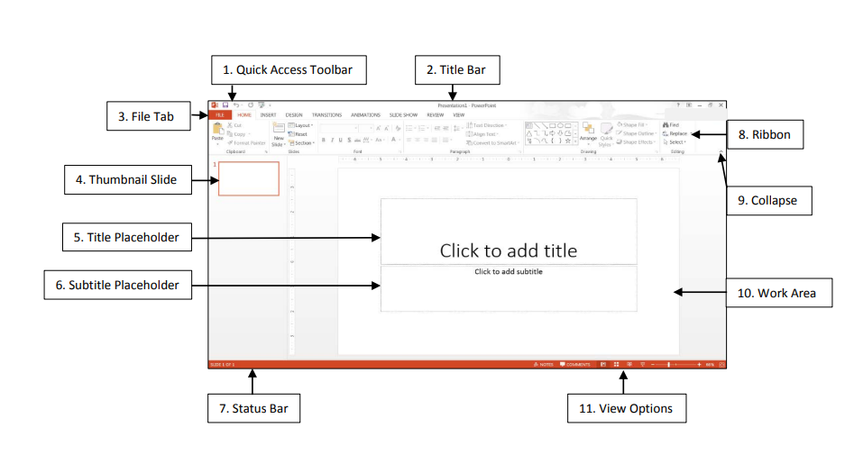

**SLIDES IN POWERPOINT:**

Slides in a presentation are similar to pages in a word processing document. All slides and graphics are saved in one file (example: keys.xppt). Use the PowerPoint file to present the information in the following ways:

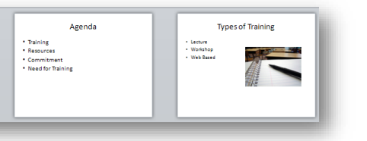

**CREATE SLIDE PRESENTATION:**

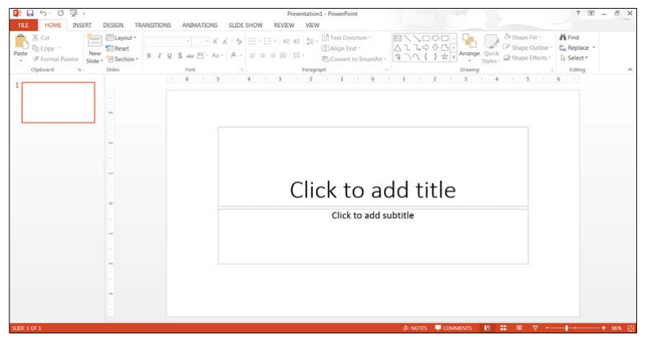

When creating a new presentation, you have choices about how to proceed. PowerPoint gives you a range of ways with which to start creating a presentation. You can start your presentation with:

* **Blank:** Slides that are unformatted and have no color scheme.
* **Design:** Slide Themes that have design concepts, fonts, and color schemes.
* **Template on Microsoft.com:** Microsoft Office Templates and Theme Gallery which are arranged according to type (Click on the **File** tab, select the **New** option, and then click on **PowerPoint presentations and slides** from the **Available Templates and Themes**.).

**DESIGN THEME:**

A Theme gives your slides a consistent appearance throughout your presentation. Themes contain color schemes with custom formatting, styled fonts, and layouts. When you apply a design template to your presentation, the slide master and color scheme of the template replaces the original blank slide.

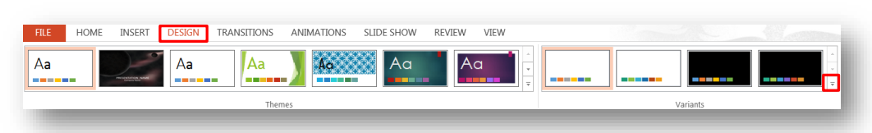

1. Select the **Design** tab, then on the **Theme** group, click on the drop-down arrow next to the last Theme.
2. The **All Themes** window will appear with available presentation Themes.

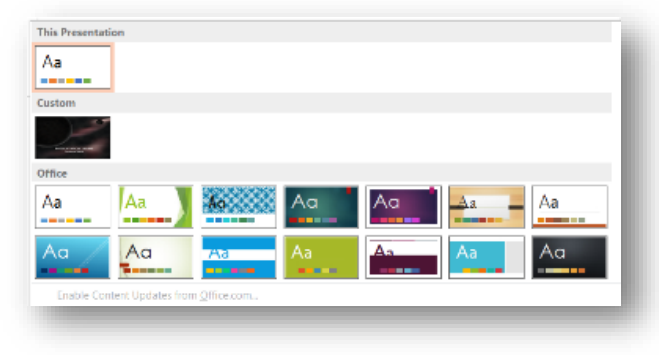

1. Hover the mouse pointer over a Theme to preview it.
2. Click on a **Theme** of your choice.

**Note:** You can change the Theme during or after the creation of your PowerPoint file.

**ADD TEXT:**

The template for the design Theme you select will determine the font type and text alignment. PowerPoint places all information (text and graphics) contained on a slide in separate **Placeholders**. Placeholders are designated by dotted lines; they appear on a slide as guides, but they will not appear on the finished presentation. In order to edit text, click once inside of the **Text Placeholder** and the insertion point will appear; then begin to type your text.



1. Click in the **Title Placeholder** and type the text title below.



1. Click in the **Subtitle Placeholder**.
2. Type the text below (You will need to press the **Enter** key after each line of text.).



1. **Save** the presentation. Click on the **File** tab and then click on **Save As**. The **Save As** window will open. In the **File name** box, type **Keys to Success** for the presentation name. The instructor will indicate where to save the file. Click on the **Save** button.

**ADD NEW SLIDE:**

A slide layout defines the placement of text, pictures, tables, and graphs. If you change the layout of a slide, the text and graphics remain intact. You can resize text and graphic boxes to conform to the new layout.

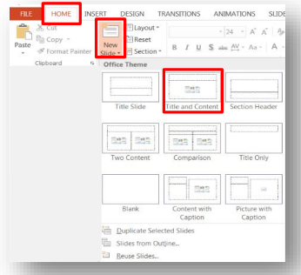

1. On the **Home** ribbon, located in the **Slides** group, click on the **New Slide** drop-down arrow. The Office Theme panel will appear with multiple slide layouts. Select your desired slide layout.
2. For this exercise, click on the second Layout (**Title and Content**) in the first row.



1. In the **Title Placeholder**, type the text **Agenda** as seen above.
2. In the **Text Placeholder**, type the bulleted text as seen above (You will need to press **Enter** after each line of text.).
3. Add another new slide.

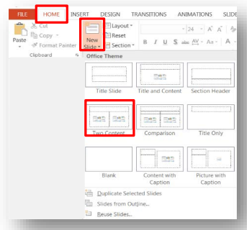

1. On the **Home** ribbon, click on the **New Slide** drop-down arrow and then select the **Two Content** slide layout (This slide contains a title, text, and clip art placeholders.).

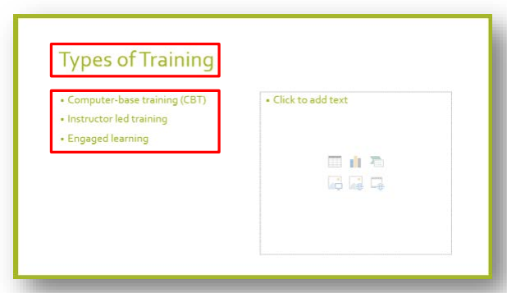

1. Click inside the **Title and Text Placeholders** and type the text shown above.



1. On the **Quick Access Toolbar**, click on the **Save** button to save your presentation changes.

**ADD PICTURES:**

Online Pictures are any type of computerized images such as artwork and photos. You can make your presentation more eye-catching and entertaining by adding Pictures.

1. Confirm you are on **slide three**.

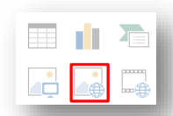

1. Click on the **Online Picture** button in the **Illustration** box, located in the **Text Placeholder**.
2. The **Bing Image Search** window will appear.

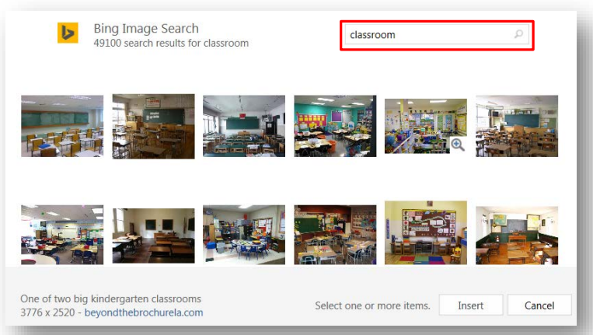

1. In the **Search** box, type the word **Classroom**, and then press the **Enter** key. A variety of online images associated with your search will appear.
2. Scroll through the **Pictures** window to find your desired image.
3. To insert the image, place the mouse pointer on the image and then click on the left mouse button twice.

**TRANSITIONS AND ANIMATIONS:**

PowerPoint allows you to apply special effects by using slide transition and text/graphical animation to make your presentation more visually appealing.

**SLIDE TRANSITION:**

Transitions are visual special effects that you see when you move from one slide to the next. Working in Normal or Slide Sorter Views allow you to set transitions for a slide. The **Transition** ribbon allows you to apply slide transitions.

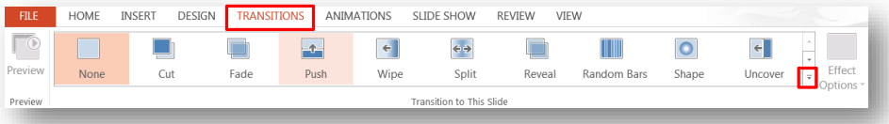

1. Go to **slide one**.
2. Click on the **Transition** tab and then click on the drop-down arrow located in the **Transition to This Slide** group to view the transition categories as seen below.

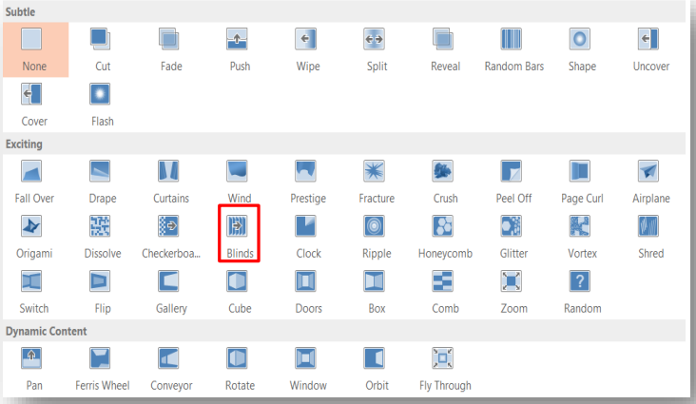

1. In the **Exciting** selection, click on the **Blinds** button. The selected slide will demonstrate this effect as you make your choice. Click on the **Preview** button located on the **Transition** ribbon to demo the effect again.
2. To apply your selection to all slides, click on the **Apply to All** button, located in the **Timing** group.
3. Notice the **transition indicator icon** on the left-hand side of the thumb print slide in Normal View.

**TEXT ANIMATION:**

Bulleted text animation refers to the progressive display of bulleted items. Bulleted items, by default, appear at the same time on a slide. When text animation is applied, bulleted list items can appear on the slide one at a time or can have motion as they display on the screen. Select the Animation ribbon to apply animation to slide text.

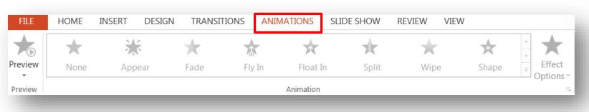

1. Confirm that you are in **Normal View** (View, Normal).
2. Go to **slide two**.
3. **Click** inside the **Text Placeholder** and select the text area.
4. Click on the **Animation** tab and then click on the drop-down arrow located in the **Animation** group to view the animation categories as seen above.

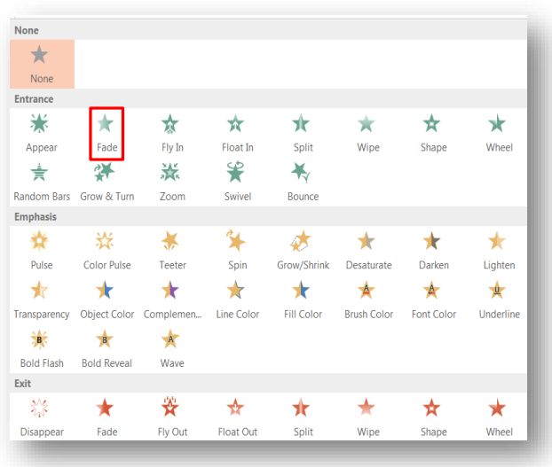

1. In the **Entrance** section, click on the **Fade** button.
2. Notice the **animation indicator** icon on the left-hand side of the thumb print slide in Normal View.

**TASKS:**

**TASK 1:** Create a Personal Introduction Presentation

Design a PowerPoint presentation to introduce yourself to your classmates. Include:

* A title slide with your name and a brief welcome message.
* A slide with basic personal information, such as where you're from, your age, and your education.
* A slide showcasing your hobbies and interests, along with relevant images or icons.
* A slide highlighting your academic goals for the semester and any challenges you anticipate.
* A slide with a picture of your favorite book or movie, a brief summary, and why you like it.
* A slide displaying a photo of your pet (if you have one or favorite pet animal) and some fun facts about them.
* A closing slide with a quote that inspires you.

**TASK 2:** Your Dream Vacation Presentation

Imagine you have the opportunity to go on your dream vacation. Create a PowerPoint presentation about this dream trip. Include:

* A title slide with the destination's name, a captivating image, and your name.
* Slides describing the location, including its geographical features and climate.
* Slides showcasing activities you'd like to do, complete with images or illustrations.
* A slide highlighting the local cuisine and a picture of a delicious dish you'd try.
* A slide with an estimated budget breakdown for the trip.
* A slide explaining why this vacation is your dream and what you hope to experience.
* A closing slide with a cheerful invitation for others to dream big and plan their ideal vacations.